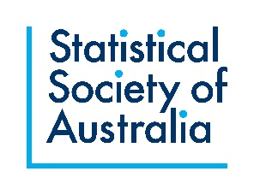
Statistical Society of Australia PhD/Masters Top-Up Scholarship
Application Form
The entire form should be 2 pages or less (2.5 pages if applying for the Australian Bureau of Statistics-supported Top-up). Please do not change the margins, line spacing or font size. You can delete explanatory text in italics.
Name:
Email address:
Gender: (we collect this for stratification purposes)
Please tick the following to confirm your eligibility for the SSA Top-Up Scholarship:
I joined the Statistical Society of Australia before 1 January 2024.
I am enrolled in a recognised masters or PhD course in Australia (see attached proof) and have at least one year remaining in my degree.
I am working in paid employment for 40 hours per fortnight or less.
If successful, I agree to being named on the website and to acknowledge the Statistical Society of Australia in any relevant presentations or publications. I agree to write a brief article at the end of my scholarship.
My PhD/Masters project is about the development of statistical/data science methodology, the assessment of statistical/data science methodology, or the development of statistical/data science software.
Degree type (tick one): Masters PhD
Current institution:
Undergraduate degree(s) (Institution, Year and Course title):
Postgraduate degree(s) (if applicable; Institution(s), Year(s) and Title(s)):
PhD/Masters project
Please include:
- A brief summary of your PhD/Masters project, including the project title, supervisory team, and main aims and how it will contribute knowledge to statistical theory and/or improve practice.
- Your progress to date on your PhD/Masters.
Your career
Please include:
- A brief summary of your career to date.
- Your plans for a career in statistics.
Eligibility for the Australian Bureau of Statistics-supported Top-Up Scholarship
If you would like your application to be considered for the Australian Bureau of Statistics-supported Top-Up, please describe how your PhD/Masters project relates to enhancing statistical methods and/or developing new methods which could be used to support the sustainable production of official statistics. This may include methods to produce insights and data products derived from an expanding suite of data sources, including traditional sources such as sample surveys, and/or other sources such as administrative and digital data (max ½ page).
Please send the completed form along with proof of enrolment to eo@statsoc.org.au.

